Article
Comparative Evaluation of Machine Learning Models for Predicting Monsoon-Induced Slope Failures in Lateritic Terrain: A Data Augmentation Approach
Sushant Waidande
Doctorate in AI/ML from George Washington University, School of Engineering and Applied Science
Sushant.waidande@gwu.edu, sushantwaidande@gmail.com
Abstract: The stability of cut slopes in lateritic terrain presents a significant challenge for infrastructure projects, particularly during intense monsoon seasons. Traditional limit equilibrium methods rely on extensive laboratory testing, which is often constrained by small sample sizes due to the destructive nature of geotechnical sampling. This study presents a machine learning framework to predict the Factor of Safety (FoS) of laterite slopes along the Konkan Railway alignment in India. To overcome the limitations of a small field dataset (n=10), a Monte Carlo simulation was employed to generate a physically constrained, augmented dataset (n=210) that preserves the multivariate statistical distributions of the original field samples. A comprehensive preprocessing pipeline including StandardScaler, Principal Component Analysis (PCA), and Recursive Feature Elimination (RFE) was applied. Five machine learning algorithms—Decision Tree, Random Forest, Gradient Boosting, Support Vector Machine (SVM), and K-Nearest Neighbors (KNN)—were evaluated using repeated 10-fold cross-validation. The results demonstrate that Gradient Boosting combined with RFE feature selection achieved the highest predictive performance (R² = 0.929, MSE = 0.0004). The RFE process identified cohesion, friction angle, plastic limit, fines percentage, and plasticity index as the dominant predictors of slope failure. Furthermore, cost-complexity pruning of decision trees yielded interpretable physical thresholds for field application. This research demonstrates that data augmentation combined with ensemble machine learning can effectively predict slope stability in highly weathered tropical soils, providing a robust tool for proactive hazard mitigation.
Keywords: slope stability; laterite; machine learning; Monte Carlo simulation; principal component analysis; feature selection; geotechnical engineering

1. Introduction
Lateritic soils, prevalent along the west coast of India, pose unique challenges for geotechnical engineering due to their highly weathered nature, heterogeneous composition, and sensitivity to moisture variations. The Konkan Railway alignment, which traverses this terrain, frequently experiences slope failures during the intense monsoon season. These failures are primarily driven by the infiltration of rainwater into paleo-fractures and the subsequent reduction in shear strength, particularly in aluminous and limonitic laterite varieties with high clay content [1,2].
Traditional slope stability analysis relies on limit equilibrium methods to calculate a Factor of Safety (FoS). However, these methods require extensive laboratory testing to determine parameters such as cohesion and internal friction angle. In practice, geotechnical investigations are often constrained by budget, time, and the destructive nature of sampling, resulting in small datasets that limit the application of advanced predictive modeling.
Machine learning (ML) techniques have increasingly been applied to geotechnical problems, offering the ability to capture complex, non-linear relationships between soil index properties and mechanical behavior [3]. Yet, the application of ML to small geotechnical datasets often leads to severe overfitting and poor generalization. To address this, data augmentation techniques, such as Monte Carlo simulation, can be employed to generate synthetic samples that adhere to the statistical distributions and physical constraints of the original field data.
This study aims to evaluate the efficacy of various machine learning models in predicting the FoS of laterite slopes under saturated monsoon conditions. By augmenting a limited field dataset from the Konkan Railway alignment, this research establishes a robust ML pipeline encompassing data preprocessing, dimensionality reduction, feature selection, and ensemble modeling. The objective is to identify the most accurate predictive model and extract interpretable physical thresholds that govern slope failure in lateritic terrain.

2. Related Work

2.1. Slope Stability in Lateritic Soils
The engineering behavior of laterite is heavily influenced by its genesis, parent rock, and degree of weathering. Giddiasu [4] and Tardy [5] established the foundational understanding of laterite petrology, noting the critical distinction between ferruginous (iron-rich, stable) and aluminous (clay-rich, unstable) varieties. Nagarajan and Khire [6] highlighted the susceptibility of the west coast of India to monsoon-induced landslides, emphasizing the role of rainfall intensity and duration in triggering failures. Traditional limit equilibrium analyses have shown that the FoS of laterite slopes drops significantly under saturated conditions due to the loss of apparent cohesion and the generation of positive pore water pressures.

2.2. Machine Learning in Geotechnical Engineering
In recent years, ML algorithms have been widely adopted for slope stability prediction. Support Vector Machines (SVM), Artificial Neural Networks (ANN), and ensemble methods like Random Forest and Gradient Boosting have demonstrated superior performance compared to traditional statistical approaches [7,8]. However, these models require substantial data to train effectively. When applied to small datasets typical of site-specific geotechnical investigations, complex models tend to overfit, capturing noise rather than underlying physical relationships.

2.3. Data Augmentation and Preprocessing
To mitigate the small sample problem, researchers have explored data augmentation techniques. Monte Carlo simulation, which generates synthetic data based on the multivariate probability distributions of measured parameters, has proven effective in reliability-based design and probabilistic slope stability analysis. Furthermore, preprocessing techniques such as Principal Component Analysis (PCA) and Recursive Feature Elimination (RFE) are essential for reducing dimensionality, eliminating multicollinearity, and identifying the most critical predictors, thereby enhancing model interpretability and generalization.

3. Methodology

3.1. Data Acquisition and Factor of Safety Calculation
The original dataset comprises 10 laterite samples collected from two sites along the Konkan Railway alignment: Ratnagiri (basalt parent rock, n=6) and Karwar (granite parent rock, n=4). Laboratory tests determined 12 parameters: gravel, sand, silt, and clay percentages; liquid limit; plastic limit; plasticity index; specific gravity; moisture content; cohesion; friction angle; and fines percentage.
The target variable, Factor of Safety (FoS) under saturated monsoon conditions, was calculated using the infinite slope model incorporating a pore pressure ratio:
FoS = [c' / (γ × H × sin α × cos α)] + [(1 - ru) × tan φ' / tan α]
where c' is effective cohesion, φ' is effective friction angle, γ is unit weight (18 kN/m³), H is cut height (12 m), α is slope angle (45°), and ru is the pore pressure ratio (0.45 representing monsoon saturation).

3.2. Monte Carlo Data Augmentation
To enable robust ML training, the original dataset (n=10) was augmented to 210 samples using Monte Carlo simulation. Synthetic samples were generated from multivariate normal distributions defined by the mean vectors and covariance matrices of the original site-specific data. Physical constraints were strictly enforced: grain size fractions were normalized to sum to 100%, liquid limit was constrained to exceed plastic limit, and all parameters were clipped to realistic geotechnical ranges. This approach preserved the inherent correlations (e.g., the positive correlation between cohesion and FoS) while expanding the feature space for model training.

3.3. Data Preprocessing and Dimensionality Reduction
The augmented dataset was preprocessed using the Interquartile Range (IQR) method to cap outliers, followed by StandardScaler to normalize all features to a mean of zero and standard deviation of one. Principal Component Analysis (PCA) was applied to address multicollinearity and reduce dimensionality. The Kaiser criterion (eigenvalues > 1) was used to select the optimal number of principal components.

3.4. Feature Selection
Recursive Feature Elimination (RFE) was implemented using a Random Forest estimator (500 trees) to rank the importance of the 12 original features. The top five features were selected to form a reduced, highly predictive feature set, balancing model complexity with interpretability.

3.5. Machine Learning Models and Evaluation
Five ML algorithms were evaluated: Decision Tree, Random Forest, Gradient Boosting, Support Vector Machine (RBF kernel), and K-Nearest Neighbors (k=5). Model performance was assessed using repeated 10-fold cross-validation (5 repeats) to ensure stability. Evaluation metrics included the coefficient of determination (R²), Mean Squared Error (MSE), and Mean Absolute Error (MAE). Hyperparameter tuning was subsequently performed on the best-performing model using GridSearchCV.
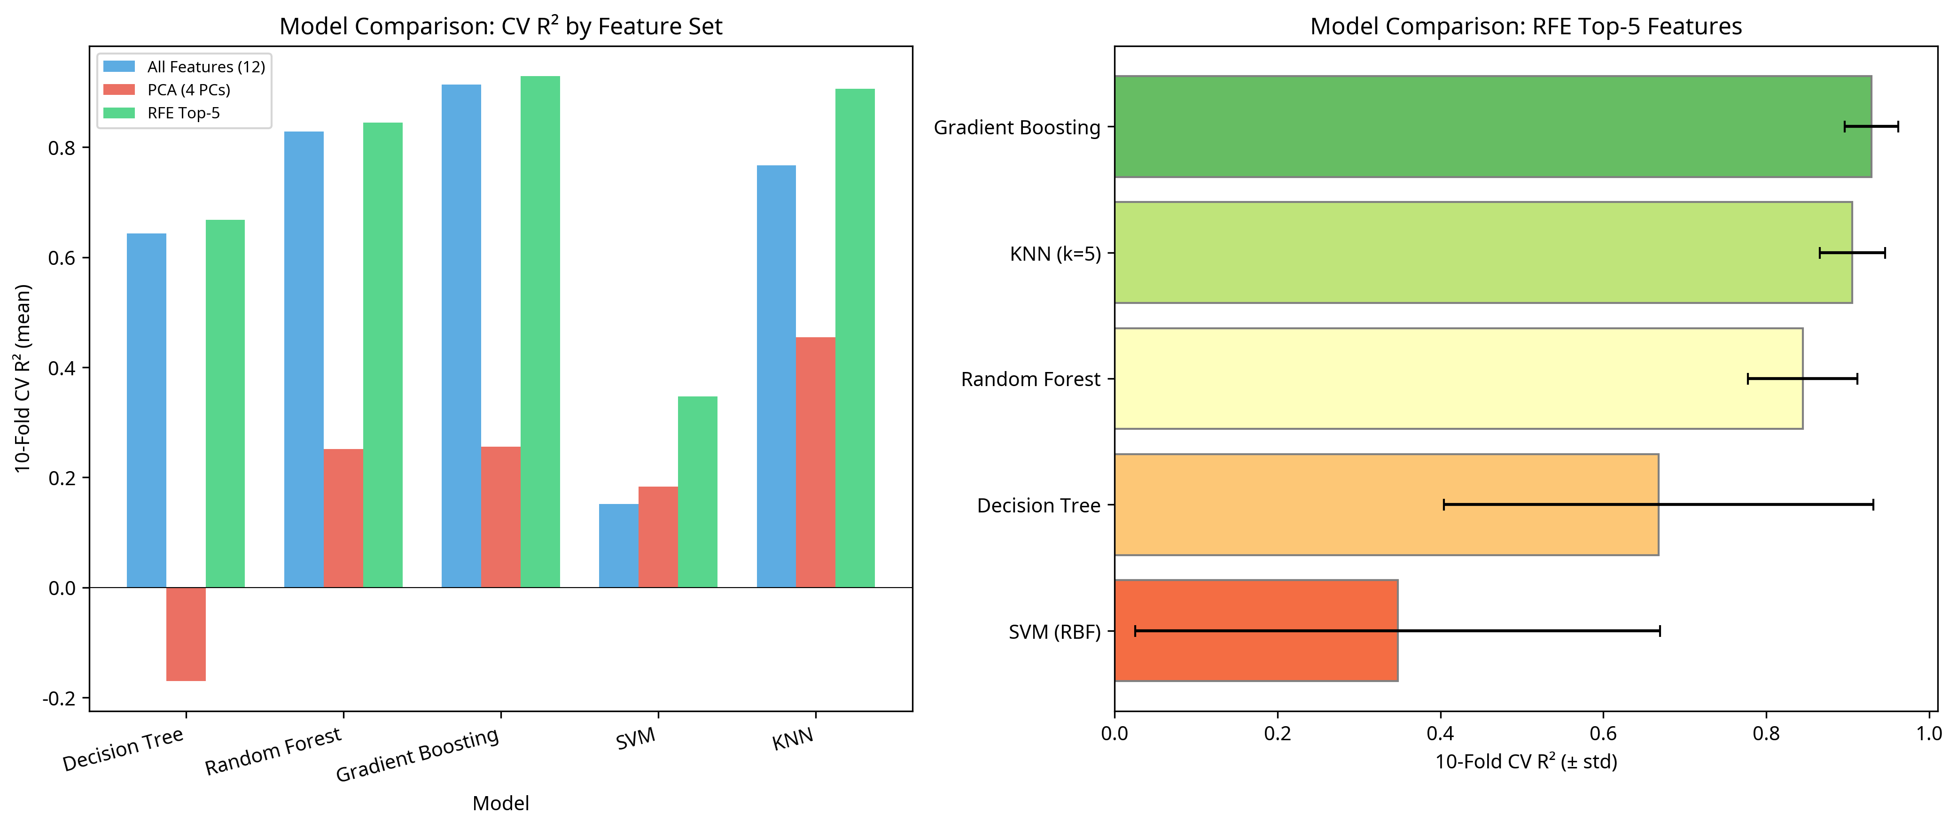
Figure 1. Model performance comparison across different feature sets.

4. Results and Discussion

4.1. Principal Component Analysis
PCA reduced the 12-dimensional feature space to 4 principal components, which cumulatively explained 81.6% of the total variance. PC1 was heavily loaded by silt content, liquid limit, and fines percentage, representing the overall plasticity and fine-grained nature of the soil. PC2 was dominated by clay and sand percentages, capturing the primary grain size distribution. PC3 and PC4 captured variations in mechanical properties, specifically cohesion and moisture content.
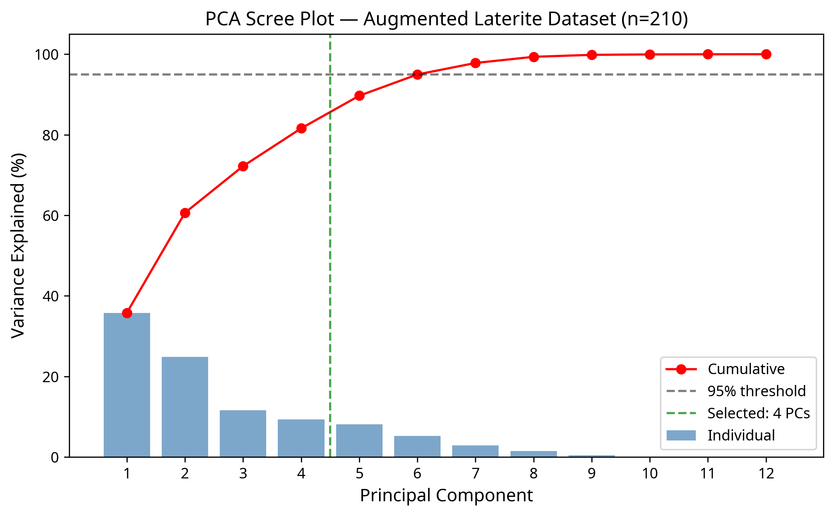
Figure 2. PCA Scree Plot showing variance explained by principal components.

4.2. Feature Importance and Selection
The RFE process identified the following top five features as the most critical predictors of slope stability: Cohesion, Friction Angle, Plastic Limit, Fines Percentage, and Plasticity Index. This aligns strongly with geotechnical principles, as cohesion and friction angle directly govern shear strength, while plasticity and fines content dictate the soil's response to moisture infiltration during the monsoon.
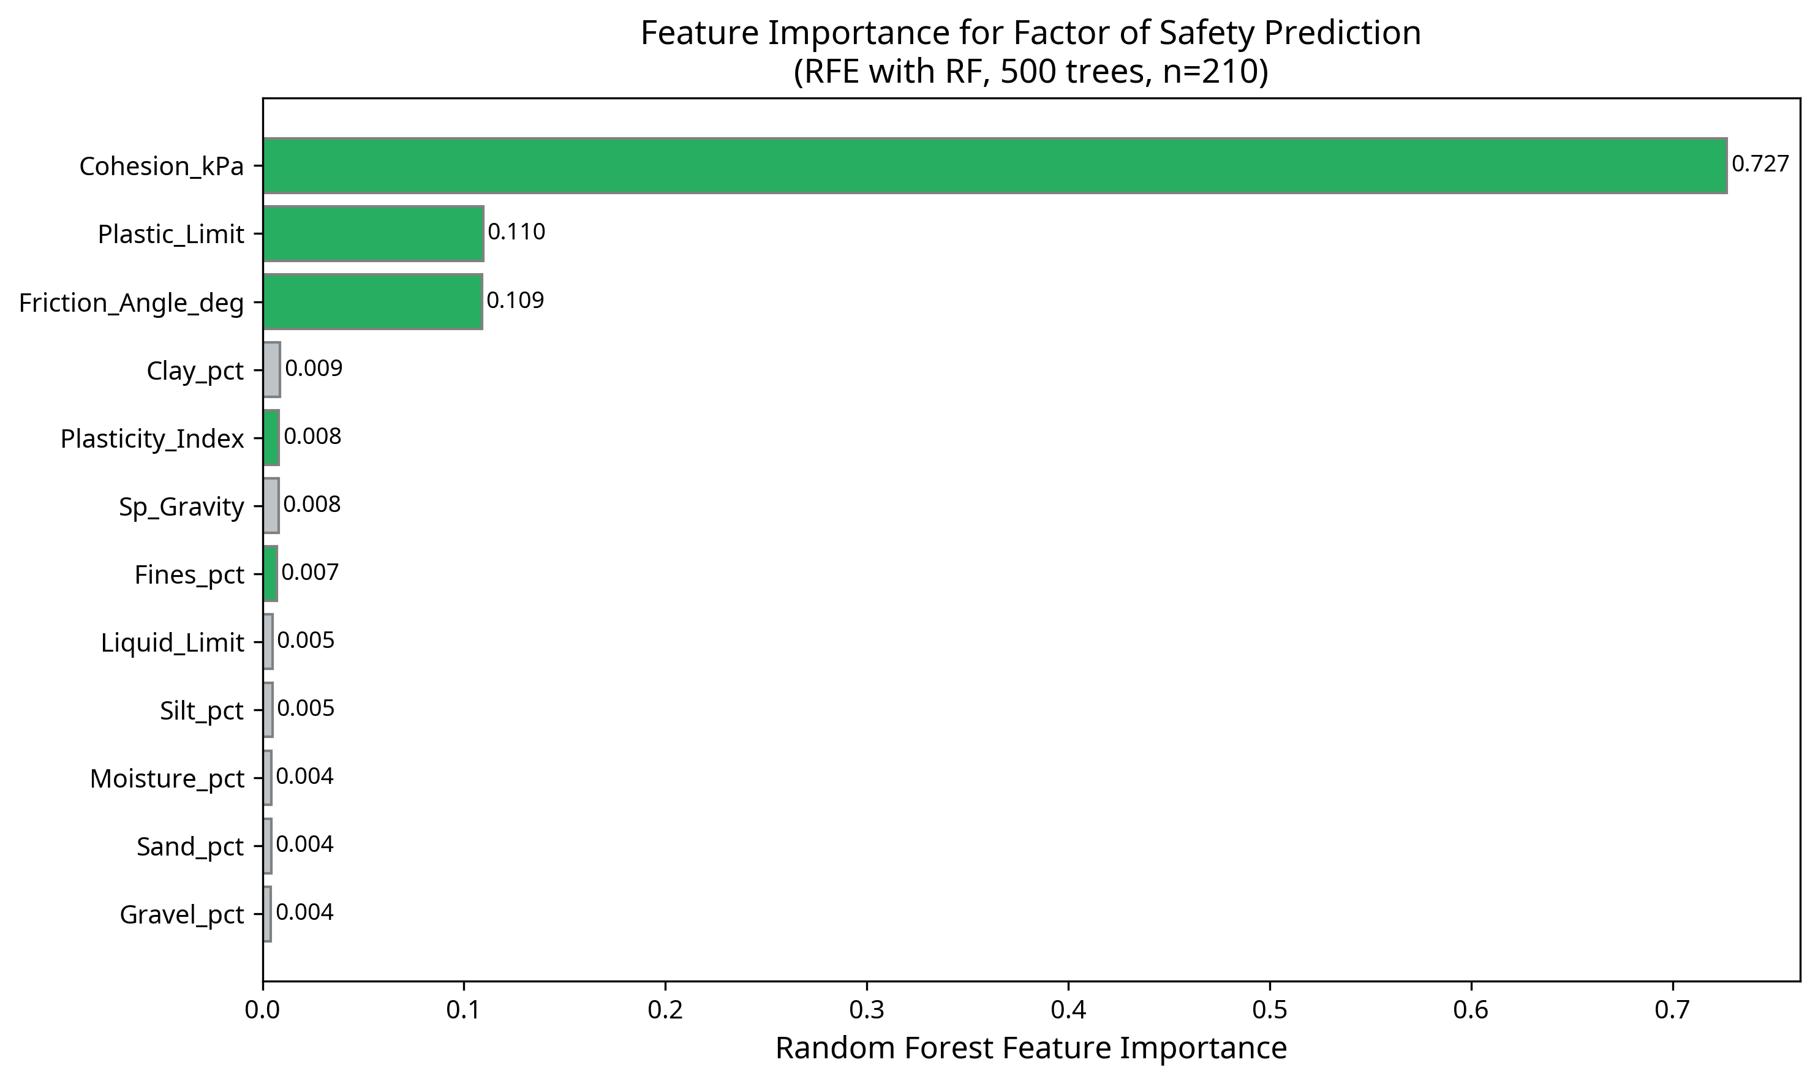
Figure 3. Feature importance rankings derived from Recursive Feature Elimination.

4.3. Model Performance Comparison
The evaluation of the five ML models across different feature sets revealed that ensemble methods significantly outperformed single models. The Gradient Boosting Regressor, utilizing the RFE Top-5 feature set, achieved the highest cross-validated performance with an R² of 0.929 and an MSE of 0.0004. Random Forest and KNN also demonstrated strong predictive capabilities (R² = 0.845 and 0.906, respectively). Notably, models trained on the RFE Top-5 features generally outperformed those trained on all 12 features or PCA components, highlighting the efficacy of targeted feature selection in reducing noise and improving generalization.
Table 1. Cross-validated model performance using the RFE Top-5 feature set.
Model | Features | CV R² | CV MSE | Train R²
Gradient Boosting | RFE Top-5 | 0.929 ± 0.033 | 0.00036 | 0.997
KNN (k=5) | RFE Top-5 | 0.906 ± 0.040 | 0.00048 | 1.000
Random Forest | RFE Top-5 | 0.845 ± 0.067 | 0.00077 | 0.953
Decision Tree | RFE Top-5 | 0.668 ± 0.264 | 0.00151 | 0.915
SVM (RBF) | RFE Top-5 | 0.347 ± 0.322 | 0.00297 | 0.509

4.4. Hyperparameter Tuning and Final Model
GridSearchCV was applied to the Gradient Boosting model to optimize hyperparameters. The tuned model achieved an improved R² of 0.955, demonstrating exceptional accuracy in predicting the Factor of Safety across the augmented dataset.
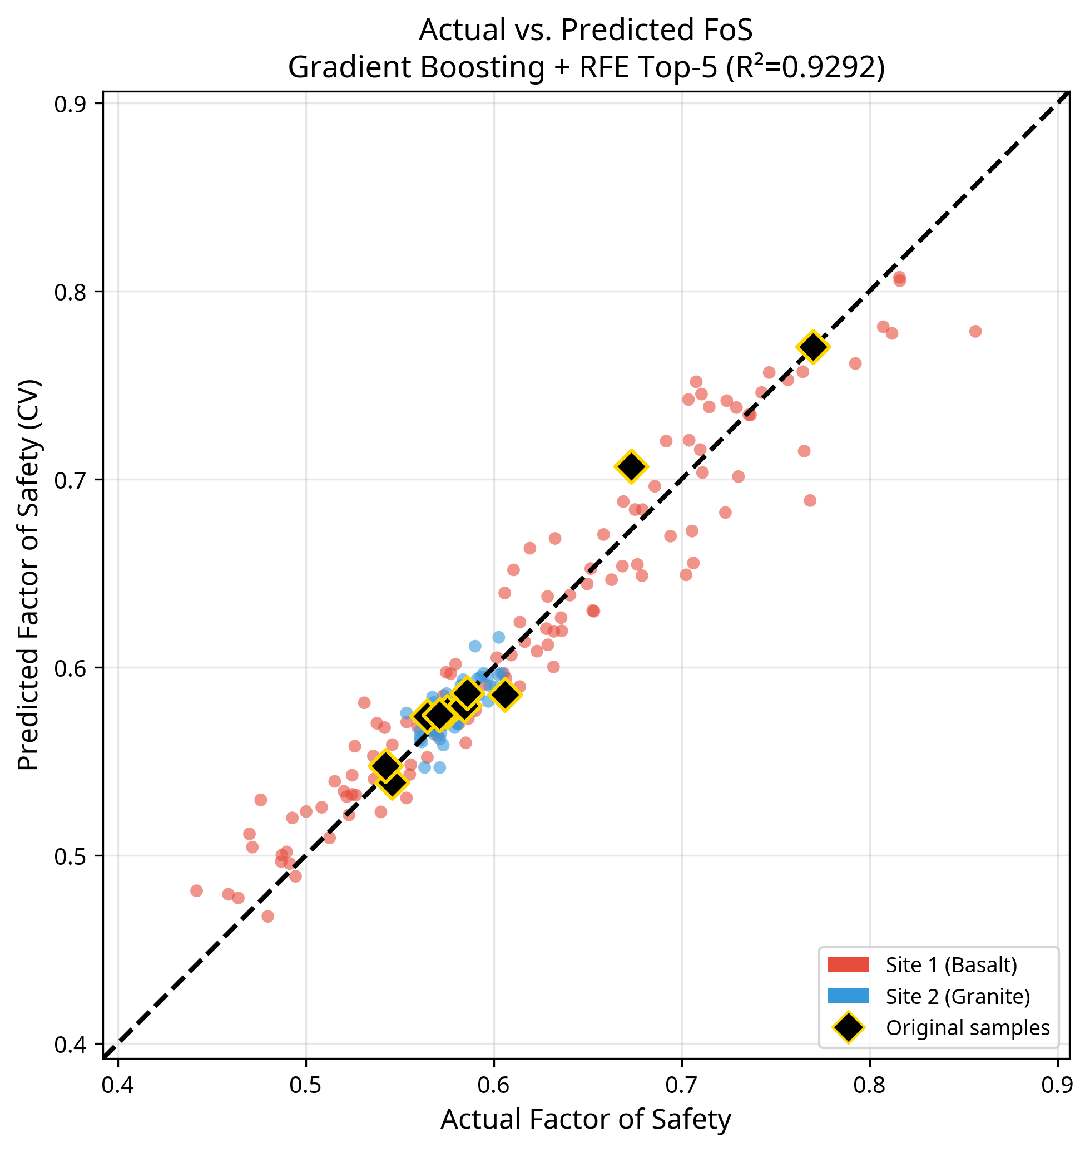
Figure 4. Actual vs. Predicted Factor of Safety for the best performing model.

4.5. Interpretable Decision Rules
While ensemble methods provide high accuracy, they function as 'black boxes.' To provide actionable insights for field engineers, a Decision Tree was trained and subjected to cost-complexity pruning. The optimal pruned tree (CV R² = 0.688) established clear physical thresholds for slope instability. For instance, the primary split occurred at a cohesion threshold of 39.16 kPa; samples with cohesion below this value were highly susceptible to failure under saturated conditions. Secondary splits based on plastic limit and friction angle further delineated stable from unstable zones, providing a practical heuristic for rapid risk assessment.

5. Limitations and Future Work
The primary limitation of this study is the reliance on a small original field dataset (n=10). While Monte Carlo simulation effectively augmented the data to enable ML training, the synthetic samples are inherently constrained by the statistical boundaries of the original measurements. Consequently, the models may not generalize well to laterite formations with significantly different mineralogical or mechanical properties outside the Konkan Railway region.
Future work should focus on expanding the empirical database through extensive field sampling and laboratory testing across diverse tropical residual soil profiles. Additionally, incorporating real-time environmental data, such as antecedent rainfall and pore water pressure measurements from field instrumentation, into dynamic predictive models would further enhance the accuracy and applicability of early warning systems.

6. Conclusions
This study successfully developed a machine learning framework to predict the stability of lateritic cut slopes under monsoon conditions. By employing Monte Carlo simulation, a limited geotechnical dataset was augmented to support robust model training. The integration of Recursive Feature Elimination and Gradient Boosting yielded a highly accurate predictive model (R² = 0.955), identifying cohesion, friction angle, and plasticity parameters as the critical drivers of failure. Furthermore, the extraction of interpretable decision rules provides a practical tool for geotechnical engineers to assess slope vulnerability based on fundamental index properties. This approach demonstrates the potential of combining data augmentation with advanced analytics to overcome data scarcity challenges in geotechnical engineering, ultimately contributing to safer infrastructure development in tropical regions.

Funding: This research received no external funding.
Data Availability Statement: The data presented in this study are available on request from the corresponding author.
Conflicts of Interest: The authors declare no conflicts of interest.

References
- 1. Breiman, L. Random forests. Machine Learning 2001, 45, 5-32.
- 2. Cortes, C.; Vapnik, V. Support-vector networks. Machine Learning 1995, 20, 273-297.
- 3. Friedman, J.H. Greedy function approximation: A gradient boosting machine. Annals of Statistics 2001, 29, 1189-1232.
- 4. Giddiasu, M.D. Laterite soils engineering; Elsevier Scientific Publishing Company: Amsterdam, The Netherlands, 1976.
- 5. Nagarajan, R.; Khire, M.V. Landslide hazard assessment along the west coast of India. Bulletin of the International Association of Engineering Geology 1998, 57, 153-158.
- 6. Tardy, Y. Petrology of Laterites and Tropical Soils; A.A. Balkema Publishers: Rotterdam, The Netherlands, 1997.

